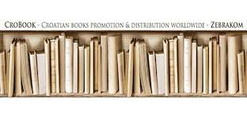


ZEBRA komunikacije d.o.o., Dubašnička 12, 10000 Zagreb – Croatia - www.zebrakom, info@zebrakom.hr

Introducing New Books from
Croatia 2/2026

Museums. Philosopy. Social Sciences. Humanities
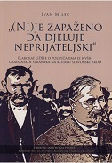
Author | Milec, Ivan
Title | "Ni(je) zapaženo da djeluje neprijateljski" : elaborat UDB-e o političarima iz bivših građanskih stranaka na kotaru Slavonski Brod
Publisher | Slavonski Brod : Hrvatski institut za povijest, Podružnica za povijest Slavonije, Srijema i Baranje, 2026
Description | 379 str. : ilustr. ; 24 cm
ISBN | 9789538102615 : EUR 26.60 US$ 31.40
Subject | Yugoslavia (1942–1992) Ministry of Internal Affairs UDBA — Documents and Archives  Intelligence service — Yugoslavia — 1945–1974 — Archival sources  Slavonski Brod (surrounding area) — Political history — 1918–1941 — Archival sources  Slavonski Brod (surrounding area) — Social conditions — 1918–1941 — Archival sources
UDC | 94(497.5)"1918/1941" * 94(497.542-37Slavonski Brod)"1918/1941"(093) * 323(497.542-37Slavonski Brod)(093)


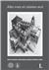
Author | Bralić, Ante (urednik)
Title | Alta voce et calamo acri 1-2 : zbornik povodom sedamdesetog rođendana Mladena Ančića
Publisher | Zadar : Sveučilište u Zadru : Hrvatska akademija znanosti i umjetnosti, Zavod za povijesne znanosti, 2026
Description | 2 sv. (544 str.; 500 str.) : ilustr. u bojama ; 30 cm
ISBN | 9789533476742 (1+2) : EUR 83.30 US$ 98.30
UDC | 930Ančić, M.(01) * 94(497.5)"07/19"
Anotation | Alta voce et calamo acri is a volume belonging to the category known as a *Festschrift*; in this instance, it marks the seventieth birthday of Mladen Ančić, Professor Emeritus at the University of Zadar. Spanning 1,043 pages across two volumes, the collection features scholarly contributions from 33 historians, art historians, archaeologists, and political scientists. The papers cover a chronological range extending from the early Middle Ages to the end of the twentieth century, while geographically focusing on Croatian lands and neighboring countries.


Title | Arheologija i popularna kultura  /Daniel Rafaelić, Ema Kosnica, Jacqueline Balen eds.
Publisher | Zagreb : Arheološki muzej u Zagrebu, 2025
Description | 156 str. ; 28 cm
Note | Katalog izložbe
ISBN | 9789538143847 : EUR 29.80 US$ 35.20
Anotation | The texts collected in this book comprise scholarly and popular-science contributions that analyze and interpret the role of archaeology in film, television, literature, and comics, as well as in music. The book offers insight into how archaeology transcends the boundaries of the discipline itself to become a significant cultural phenomenon recognized even in the everyday life of contemporary society and demonstrates that popular culture is not merely a superficial interpretation of archaeology, but a powerful medium for disseminating knowledge, sparking public interest, and fostering a sense of responsibility toward the heritage of the past.


Author | Žagar, Davorin
Title | Čari političkoga u queer perspektivi : Prilog Machiavellijevu djelu mišljenja
Publisher | Zagreb : Disput, 2026
Description | 146 str. ; 22,5 cm
ISBN | 9789532605389 : EUR 17.00 US$ 20.00
Anotation | How can one read Machiavelli “against the grain,” and what does his thought signify for our contemporary political experience? What is the connection between LGBTIQ+ issues and the Florentine’s political thought? This study ingeniously links the democratic and feminist facets of Machiavelli. An alternative image emerges for the reader: that of a new, plebeian queer ruler a drag performer whose emancipatory potential manifests in the utopian envisioning of a different reality, thereby opening a horizon of hope for the future and igniting plebeian creative action.

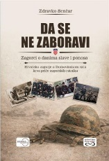
Author | Senčar, Zdravko
Title | Da se ne zaboravi : Zagorci o danima slave i ponosa : Hrvatsko zagorje u Domovinskom ratu kroz priče zagorskih ratnika
Publisher | Zagreb : Despot Infinitus, 2026
Description | 327 str. : ilustr. ; 24 cm
ISBN | 9789533662350 : EUR 33.20 US$ 39.20
Subject | Domovinski rat -- Vojne postrojbe -- Hrvatsko Zagorje
UDC | 355.31(497.5)

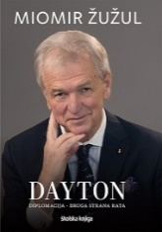
Author | Žužul, Miomir
Title | Dayton : diplomacija - druga strana rata
Publisher | Zagreb : Školska knjiga, 2026
Description | 235 str., [12] lista s tablama : ilustr. ; 24 cm
ISBN | 9789530626003 : EUR 34.50 US$ 40.70
UDC | 341.382(771Dayton)"1995"
Anotation | *Dayton: Diplomacy – The Other Side of the War* is the testimony of Miomir Žužul, one of the key participants in that process; it is written in a sober, impartial manner—like the recording of a camera capturing all those turbulent events from the sidelines.

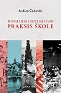
Author | Čakardić, Ankica
Title | Dionizijski socijalizam Praksis škole  Jugoslavenska marksistička filozofija i feminističko reispisivanje
Publisher | Zaprešić : Fraktura, 2026
Description | 384 str. ; 24 cm
ISBN | 9789533588582 : EUR 37.20 US$ 43.90
UDC | Ankica Čakardić’s study Dionizijski socijalizam Praksis škole is a pioneering undertaking in many respects the first detailed reconstruction of one of the most exciting chapters in the intellectual history of socialism. Yet, the true novelty of this important book lies not in its inspired account of the Yugoslav Praxis School an intellectual movement that, from the 1960s to the mid-1970s, shaped the boldest critique of Stalinism and bureaucratic socialism but rather in the author’s “ruthlessly critical” analysis of its philosophical ideas, through which she offers a hitherto non-existent feminist re-examination of that most prominent intellectual tradition of socialist Yugoslavia.

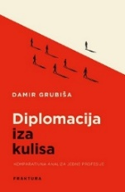
Author | Grubiša, Damir
Title | Diplomacija iza kulisa : komparativna analiza jedne profesije
Publisher | Zaprešić : Fraktura, 2026
Description | 526 str. ; 24 cm
ISBN | 9789533588599 : EUR 42.50 US$ 50.20
UDC | 327.82 * 341.7
Anotation | The book Diplomacija iza kulisa by Damir Grubiša is the work of a former diplomat and professor emeritus at the Faculty of Political Science in Zagreb and the American University of Rome. In this book, Grubiša combines extensive experience and a thorough knowledge of the subject matter with rare erudition.


Author | Vanga, Vera
Title | Dobrovoljna diplomacija u Domovinskom ratu : Hrvatski ured pri Promatračkoj misiji Europske zajednice
Publisher | Zagreb : Despot Infinitus, 2026
Description | 325 str. : ilustr. ; 28 cm
ISBN | 9789533662404 : EUR 33.20 US$ 39.20
UDC | 327(497.5)
Anotation | "The Croatian Office." Nothing more needed to be said, nor was any further explanation required to clarify what kind of office it was. And that office was filled with people volunteers. A small number were physically present at all times, while many more maintained constant contact. Some were in the field, others on standby always ready to go wherever necessary and do whatever was required. Students, professors, generals, pilots, intelligence officers, diplomats, the unemployed individuals from all walks of life wanted to help the Croatia of their dreams, a country that, at the time, was truly an abstraction.

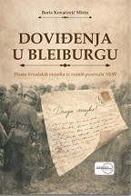
Author | Kovačević Mirin, Boris
Title | Doviđenja u Bleiburgu : pisma hrvatskih vojnika iz vojnih postrojbi NDH
Publisher | Zagreb : Despot Infinitus, 2026
Description | 287 str. ; 24 cm
ISBN | 9789533662381 : EUR 27.70 US$ 32.70
Subject | Vojnici -- Nezavisna Država Hrvatska – Korespondencija  Drugi svjetski rat (1939.-1945.) -- Hrvatske vojne postrojbe
UDC | 355.11(497.5)
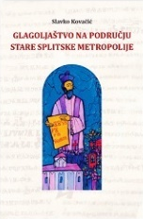

Author | Kovačić, Slavko
Title | Glagoljaštvo na području stare Splitske metropolije
Publisher | Zagreb : Staroslavenski institut ; Split : Filozofski fakultet : Katolički bogoslovni fakultet, Centar "Don Frane Bulić",  2025
Description | 526 str. : ilustr. u bojama ; 25 cm
ISBN | 9789533521251 : EUR 41.70 US$ 49.20
Subject | Glagoljaštvo – Dalmacija. Glagoljski rukopisi – Dalmacija. Glagoljski natpisi – Dalmacija. Glagoljske knjige
UDC | 272-772(497.583)-9 * 091:003.349(497.58)

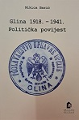
Author | Barić, Nikica
Title | Glina : 1918. - 1941. : politička povijest
Publisher | Zagreb : Hrvatski institut za povijest, 2026
Description | 150 str. : graf. prikazi ; 25 cm
ISBN | 9789538335709 : EUR 16.00 US$ 18.90
 | Beginnings in the New State (1918–1929): Following the collapse of Austria-Hungary, the population of the Glina region found itself in a new state dominated by centralist policies. Croats largely opposed unitarism and supported the policies of Radić, whereas the Serb population predominantly supported the regime's parties. The January 6th Dictatorship and Divisions: With the imposition of the dictatorship in 1929 and the subsequent division into *banovinas* (provinces), Glina became part of the Sava Banovina, and from 1939, the Banovina of Croatia. Political life was marked by censorship and the persecution of the regime's political opponents.
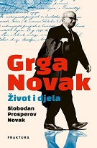

Author | Prosperov Novak, Slobodan
Title | Grga Novak - Život i djela
Publisher | Zaprešić : Fraktura, 2026
Description | 312 str. ; 24 cm
ISBN | 9789533589770 : EUR 31.90 US$ 37.60
UDC | The biography *Grga Novak: Life and Works* tells the story of the scholar and archaeologist from Hvar the only Croat to be awarded the knighthood (the title of "Sir") by Queen Elizabeth II. Slobodan Prosperov Novak traces his journey from poverty to the pinnacle of academia across the regimes of the 20th century.
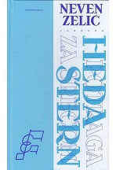

Author | Zelić, Neven
Title | Heda Stern : potraga za srećom
Publisher | Zagreb : Feldman & Co., 2025
Description | 390 str. : ilustr. (djelomice u bojama) ; 24 cm.
ISBN | 9789534664414 : EUR 44.00 US$ 51.90
Subject | Stern, Heda. Holokaust (1939.-1945.) -- Nezavisna Država Hrvatska
UDC | 929Stern, H.

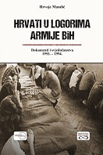
Author | Mandić, Hrvoje
Title | Hrvati u logorima Armije BiH : dokumenti i svjedočanstva : 1993. – 1994.
Publisher | Zagreb : Despot Infinitus, 2026
Description | 268 str. ; 21 cm
ISBN | 9789533662466 : EUR 33.20 US$ 39.20
Anotation | While the suffering of Bosniak civilians in camps run by the authorities of Republika Srpska as well as those run by the authorities of Herceg-Bosna has been extensively documented and prosecuted by domestic and international courts, the experiences of Croat civilians in camps run by the Army of BiH have remained significantly less explored.  Hrvoje Mandić’s book seeks to fill this historiographical gap by offering a detailed historical overview of the Croat-Bosniak conflict during the war in BiH.

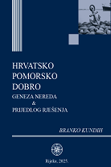
Author | Kundih, Branko
Title | Hrvatsko pomorsko dobro : geneza nereda & prijedlog rješenja
Publisher | Rijeka : Kundih savjetovanja, 2025
Description | 431 str. ; 25 cm
ISBN | 9789534648506 : EUR 116.70 US$ 137.70
Subject | Pomorsko dobro -- Pravna regulativa – Hrvatska
UDC | 341.225(497.5) * 351.711(497.5)(094)

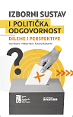
Title | Izborni sustav i politička odgovornost : dileme i perspektive  / Obadić, Ivan (urednik) (autor teksta) et al.
Publisher | Zagreb : Centar za demokraciju i pravo Miko Tripalo : Fakultet političkih znanosti, 2026.
Description | V, 333 str. ; 24 cm.
ISBN | 9789538174230 : EUR 50.00 US$ 59.00
UDC | 321.7 * 17:32
Anotation | The book contains eleven papers that systematically and argumentatively address the legal, constitutional, political, and social aspects of political responsibility and the functioning of the electoral system in contemporary Croatia, while providing valuable insights into the challenges and possibilities for its further improvement.

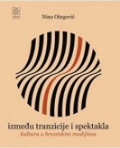
Author | Ožegović, Nina
Title | Između tranzicije i spektakla : kultura u hrvatskim medijima
Publisher | Zagreb : Meandar media, 2026
Description | 399 str. ; 21 cm
ISBN | 9789533343587 : EUR 31.90 US$ 37.60
Subject | Kultura i masovni mediji – Hrvatska. Kultura -- Medijsko izvještavanje -- Hrvatska  Hrvatska -- Kulturna politika -- 1990.-2000. Hrvatska -- Kulturna politika -- 2000.-2010
UDC | 316.774:008(497.5) * 008(497.5) * 304.4(497.5)

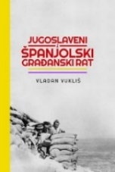
Author | Vukliš, Vladan
Title | Jugoslaveni i Španjolski građanski rat
Publisher | Zagreb : Srednja Europa, 2026
Description | IX, 571 str. : ilustr., zemljop. karte i crteži ; 24 cm
Note | Prijevod djela: Jugosloveni i Španski građanski rat
ISBN | 9789533870830 : EUR 36.20 US$ 42.70
Subject | Španjolski građanski rat (1936.-1939.) -- Internacionalne brigade. Jugoslaveni -- Vojna povijest  Europa -- Vojna povijest -- 20. st
UDC | 94(460=163)"1936/1939" * 355.48(460=163)"1936/1939"


Author | Dragičević, Berta
Title | Kako smo živjeli
Publisher | Zagreb : Durieux, 2026
Description | 128 str. : ilustr. (djelomice u bojama), faks. ; 21 cm
ISBN | 9789531886086 : EUR 22.30 US$ 26.30
Subject | Dragičević, Berta -- Djetinjstvo i mladost
UDC | 821.163.42-94

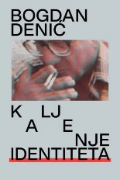
Author | Denitch, Bogdan Denis
Title | Kaljenje identiteta
Publisher | Zagreb : Srpsko narodno vijeće : Sandorf, 2026
Description | 364 str. ; 24 cm
ISBN | 9789537442828 : EUR 21.30 US$ 25.10
UDC | 929Denitch, B. D. * 329‑024.526(73)(091)
Anotation | The autobiography and story of the democratic left in two countries by Bogdan Denić (1929 – 2016) bears witness to a life shaped at the crossroads of countries, languages ​​and ideologies. Sociologist, political theorist, university professor and activist, one of the founders of the Democratic Socialists of America (DSA) and a significant figure in the peace movement during the Yugoslav wars of the nineties, Denić spent most of his life between the United States of America and first Yugoslavia, then Serbia and Croatia between theory and political practice, hope and disappointment.


Author | Valentinčič Furlan, Nadja
Title | Knowledge and Identities in Intangible Heritage and Film : Dry Stone Walling
Publisher | Zagreb : Srednja Europa ; Ljubljana : Založba Univerze v Ljubljani; Znanstvena založba Filozofske fakultete : Slovenski etnografski muzej, 2026
Description | 298 str. : ilustr. u bojama ; 24 cm
Note | Prijevod djela: Znanje in identitete v filmih o nesnovni kulturni dediščini ; Summary
ISBN | 9789533870779 : EUR 30.80 US$ 36.40
Subject | Etnografski film. Vizualna antropologija. Nematerijalna kulturna baština. Kulturna baština – Zaštita. Suhozidi
UDC | 39-028.22 * 791.229 * 7.025.3/.4


Author | Bošnjak,Milan ; Holjevac,Željko - editors
Title | Kosinjska dolina – jučer, danas i sutra. Zbornik radova
Publisher | Zagreb : Institut društvenih znanosti Ivo Pilar, 2025
Description | 600 str. : 24 cm
ISBN | 9789538404368 : EUR 23.40 US$ 27.60
 | The scientific and professional conference Kosinjska dolina – yesterday, today and tomorrow was organized with the aim of creating a critically examined public image of the Kosinjska dolina with its heritage strongholds and development perspective.

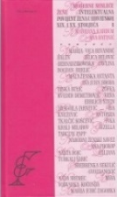
Author | Kardum, Marijana ; Batinić, Ana
Title | Moderne misleće žene : intelektualna povijest žena u Hrvatskoj 19. i 20. stoljeća
Publisher | Zagreb : Feldman & Co, 2025.
Description | 629 str. ; 24 cm
ISBN | 9789534664421 : EUR 77.40 US$ 91.30
Subject | Intelektualke -- Hrvatska – Povijest. Žene -- Hrvatska -- Intelektualni život -- Povijest  Žene -- Hrvatska -- Društveni uvjeti -- 19. st Žene -- Hrvatska -- Društveni uvjeti -- 20. st
UDC | 305-055.2(497.5)(091) * 94-055.2(497.5) * 94-057.85(497.5
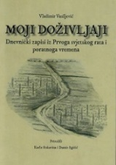

Author | Vasiljević, Vladimir
Title | Moji doživljaji : dnevnički zapisi iz Prvoga svjetskog rata i poratnoga vremena
Publisher | Zagreb : Srednja Europa, 2026
Description | XLVII, 384 str. : ilustr. ; 24 cm
Note | Str. VII-XLV: Vladimir Vasiljević i njegov dnevnik / Karlo Rukavina
ISBN | 9789533870731 : EUR 30.80 US$ 36.40
Subject | Vasiljević, Vladimir – Dnevnici. Prvi svjetski rat (1914.-1918.) -- Sudjelovanje -- Srbi -- Arhivski izvori
UDC | 94(4)"1914/1918" * 355Vasiljević, V.

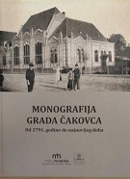
Author | Turk, Zoran (urednik) ; Vuković, Saša (urednik)
Title | Monografija grada Čakovca
Publisher | Čakovec : Matica hrvatska, Ogranak : Grad Čakovec : Muzej Međimurja, 2025
Description | 385 str. : ilustr. u bojama ; 32 cm
ISBN | 9789538488214 : EUR 42.60 US$ 50.30
Subject | Čakovec – History. Čakovec – Cultural history. Čakovec – Politics and government.
UDC | 908(497.524Čakovec

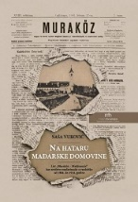
Author | Vuković, Saša
Title | Na hataru mađarske domovine : List „Muraköz – Medjimurje“ kao sredstvo mađarizacije u razdoblju od 1884. do 1914. godine
Publisher | Čakovec : Matica hrvatska, Ogranak, 2026
Description | XV, 199 str. : ilustr. ; 24 cm
ISBN | 9789538488306 : EUR 25.00 US$ 29.50
Subject | Muraköz – Medjimurje (novine). Mađarizacija – Međimurje.Međimurje -- Povijest
UDC | 94(497.524)"18/19" * 323.13(497.524=511.141


Author | Petrić, Hrvoje
Title | Nikola VII. Zrinski Čakovečki : (1620. – 1664.) : snovi prekinuti u lovu na vepra
Publisher | Samobor : Meridijani ; Čakovec : Zrinska garda Čakovec : Matica hrvatska, Ogranak, 2026
Description | 357 str. : ilustr. u bojama ; 26 cm
ISBN | 9789532392739 : EUR 42.60 US$ 50.30
UDC | 94(497.5)Zrinski, N. * 929.73Zrinski, N. * 94(497.5)"16"
Anotation | Ban Nikola VII Zrinski (Čakovec, May 3, 1620 – Otok Forest near Kuršanec/Kuršanečki Lug, November 18, 1664) is undoubtedly one of the most prominent figures in 17th-century Croatian and Hungarian history; during his lifetime, he was regarded as a "hero to whom Providence had entrusted the fate of Europe," and immediately after his death, he was hailed as the "Father of the Croatian Homeland."  Historian Hrvoje Petrić now presents for the first time in Croatian historiography a comprehensive monographic account of the life and work of this distinguished Croatian Ban, whose life was abruptly cut short at the age of 44 by a tragic and unfortunate death during a wild boar hunt.

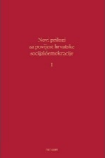
Author | Globačnik, Matko (urednik)
Title | Novi prilozi za povijest hrvatske socijaldemokracije - sv. I
Publisher | Zagreb : Plejada, 2026
Description | 150 str. : ilustr. ; 24 cm
ISBN | 9789538549076 : EUR 19.20 US$ 22.70
UDC | 329.14(497.5)(091
Anotation | This collection of papers was published to mark significant anniversaries related to Croatian social democracy. The year 2024 marks the 150th anniversary of the birth (November 24, 1874) and the 100th anniversary of the death (March 1, 1924) of Vilim Bukšeg, a leading figure in Croatian social democracy and a pioneer in organizing trade unions in Croatia. The same year also marks the 130th anniversary of the founding (September 8–9, 1894) of the Social Democratic Party of Croatia and Slavonia.

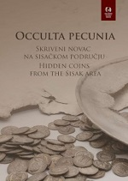
Author | Boras Brlić, Ivana et al
Title | Occulta pecunia : [Skriveni novac na sisačkom području = Hidden coins from the Sisak area]
Publisher | Sisak : Gradski muzej Sisak, 2025
Description | 85 str. : ilustr. u bojama ; 30 cm.
Note | Katalog izložbe održane u sklopu programa Noći muzeja, 31. 1. - travnja 2025. u Gradskom muzeju Sisak
ISBN | 9789538389245 : EUR 40.50 US$ 47.80
Subject | Arheološki nalazi -- Sisak (okolica) -- Katalozi izložbi. Kovani novac -- Sisak (okolica) -- Katalozi izložbi
UDC | 904:737(497.527-37Sisak)"652/654" * 737.1(497.527-37Sisak)

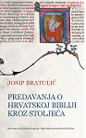
Author | Bratulić, Josip
Title | Predavanja o hrvatskoj Bibliji kroz stoljeća
Publisher | Zagreb : Hrvatska sveučilišna naklada : Hrvatsko katoličko sveučilište, 2025
Description | 224 str. ; 21 cm
Note | Str. 9-11: Riječ urednika / Mateo Žagar i Anita Šikić
ISBN | 9789531695626 : EUR 19.20 US$ 22.70
UDC | 27-27 * 27-234
Anotation

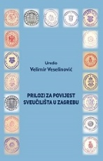
Author | Veselinović, Velimir
Title | Prilozi za povijest Sveučilišta u Zagrebu
Publisher | Zagreb : Filozofski fakultet u Zagrebu, FF press, 2025
Description | 570 str. ; 26 cm
ISBN | 9789533791722 : EUR 42.60 US$ 50.30
Subject | Sveučilište (Zagreb) – Povijest. Visoko školstvo -- Zagreb -- Povijest
UDC | 378.4(497.521.2)

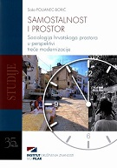
Author | Poljanec-Borić, Saša
Title | Samostalnost i prostor. Sociologija hrvatskoga prostora u perspektivi treće modernizacije
Publisher | Zagreb : Institut društvenih znanosti Ivo Pilar, 2026
Description | 216 str. ; 24 cm
ISBN | 9789538404511 : EUR 23.40 US$ 27.60
Anotation | The book is a compendium of eleven articles analysing, at various levels, spatial changes from an interdisciplinary social science perspective, during Croatia’s third modernisation. The author analyzes the spatial and political origins of the problem, draws well-founded conclusions, and proposes solutions to address the identified issues. Her analyses, grounded in the sociology of space, transcend the boundaries of urban or rural sociology, addressing regional factors that influence security, social equity, ecological balance, and urban planning.

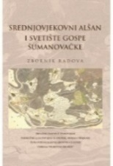
Author | Znanstveno-stručni skup Srednjovjekovni Alšan i Svetište Gospe Šumanovačke (2023 ; Šumanovci)  Bilić, Anica (urednik)
Title | Srednjovjekovni Alšan i Svetište Gospe Šumanovačke : zbornik radova Znanstvenog skupa održanog u Šumanovcima 1. lipnja 2023.
Publisher | Slavonski Brod : Hrvatski institut za povijest, Podružnica za povijest Slavonije, Srijema i Baranje, 2026.
Description | 203 str. : ilustr. ; 24 cm
ISBN | 9789538102585 : EUR 20.30 US$ 23.90
Subject | Marija -- Kult – Šumanovci. Svetište Skrovite Gospe Šumanovačke -- Povijest -- Zbornici s konferencija  Šumanovci -- Religiozni život i običaji -- Crkvena povijest -- Zbornici s konferencija
UDC | 272-522(497.541Šumanovci)-9 * 2-523(497.541Šumanovci)


Author | Miletić, Aleksandar R.
Title | Stambeni pakao : sustav kontrolirane stanarine u Jugoistočnoj i Srednjoistočnoj Europi (1914-1930
Publisher | Zagreb : Srednja Europa, 2026
Description | 319 str. : graf. prikazi ; 24 cm
Note | Izv. stv. nasl.: Stambeni pakao : sistem kontrolisane stanarine u Jugoistočnoj i Istočnoj Srednjoj Europi, 1914–1930
ISBN | 9789533870823 : EUR 29.80 US$ 35.20
Subject | Stambena politika -- Europa, jugoistočna -- Povijest
UDC | 332.8(4-12)(091


Author | Gabelica, Mislav
Title | Svećenik i političar Juraj Tomac (1866. – 1930.)
Publisher | Zagreb : Institut društvenih znanosti Ivo Pilar, 2026
Description | 216 str. ; 24 cm
ISBN | 9789538404528 : EUR 23.40 US$ 27.60
Anotation | The book provides a well-grounded and comprehensive overview of the political and social activities of a prominent, socially engaged figure at the local level during a period of profound state, legal, and political transformations in Croatia spanning from the late 19th century to the establishment of the monarchist Yugoslav dictatorship.

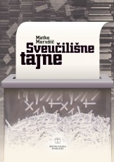
Author | Marušić, Matko
Title | Sveučilišne tajne
Publisher | Zagreb : Medicinska naklada, 2025
Description | 250 str. ; 21 cm
ISBN | 9789533682150 : EUR 39.70 US$ 48.40
UDC | 378.4 * 378.4(497.5
Anotation | The book Sveučilišne tajne is authored by Professor Emeritus Matko Marušić, reflecting his characteristic style marked by openness, clarity, and a balanced presentation as well as his tendency to rely on data and evidence. It analyzes university life and work in general, as well as each Croatian university individually, while providing a detailed comparison of teaching and research data from the universities of Osijek, Rijeka, Split, and Zagreb against their counterparts in Belgrade, Budapest, and Ljubljana institutions similar in terms of tradition, environment, and size.
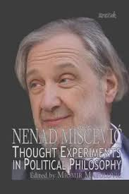

Author | Miščević, Nenad
Title | Thought Experiments in Political Philosophy : Essays 2012–2022
Publisher | Zagreb : Kruzak, 2026
Description | 290 str. ; 21 cm
ISBN | 9789536463619 : EUR 27.70 US$ 32.70
Subject | Filozofija politike. Analitička filozofija
UDC | 165.731 * 167.2 * 1:32

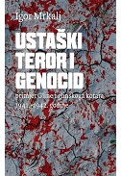
Author | Mrkalj, Igor
Title | Ustaški teror i genocid : primjer Gline i glinskoga kotara 1941. - 1942. godine
Publisher | Zagreb : Srpsko narodno vijeće ; Profil knjiga, 2026
Description | 790 str. : ilustr., zemljop. crteži ; 24 cm
ISBN | 9789537442545 : EUR 41.70 US$ 49.20
UDC | 94(497.5)"1941/1945" * 341.48(497.527Glina=163.41)(091)
Anotation | In this pioneering and extraordinary case study of the mass murders in Glina and the Glina district (1941-1942), Igor Mrkalj offers an in-depth analysis of the social processes that led to the genocide, the trajectory of the genocide and its consequences. The book is based on meticulous and thorough research that offers us a new understanding of what happened in Glina in the very early period of Ustasha rule.


Author | Ogrizović, Slava
Title | Zagreb se bori : posveta slobodi i nepokorenom gradu
Publisher | Zagreb : Media bar, 2026
Description | 331 str. ; 23 cm
Note | Str. 323-331: Pogovor / Tvrtko Jakovina
ISBN | 9789538357336 : EUR 29.10 US$ 34.30
Subject | Narodnooslobodilački rat u Jugoslaviji (1941.-1945.) -- Zagreb -- Svjedočanstva  Drugi svjetski rat (1939.-1945.) -- Hrvatska – Svjedočanstva. Zagreb -- Povijest -- 1941.-1945
UDC | 94(497.5)"1941/1945" * 355.48(497.5) * 355.4(497.521.2) * 355Ogrizović, S.


Author | Bonfiglioli, Chiara
Title | Žene i industrija na Balkanu : uspon i pad tekstilne industrije u Jugoslaviji
Publisher | Zagreb : Srednja Europa, 2026
Description | 251 str. . ilustr. ; 23 cm
Note | Prijevod djela: Women and industry in the Balkans: the rise and fall of the Yugoslav textile sector
ISBN | 9789533870915 : EUR 29.80 US$ 35.20
Subject | Women textile workers -- Yugoslavia – History  Textile industry -- Social aspects -- Yugoslavia -- History
UDC | 305-057.2(497.1) * 677-057.2(497.1) * 305-055.2(497.1

Linguistics. Philology
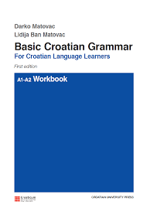
Author | Matovac, Darko
Title | Basic Croatian Grammar : for Croatian Language Learners A1-A2 : workbook
Publisher | Zagreb : Hrvatska sveučilišna naklada, 2026
Description | 431 str. ; 24 cm
ISBN | 9789531695657 : EUR 32.10 US$ 37.90
Anotation | The Basic croatian grammar A1-A2 – workbook grounded in theory and proven in practice enables the systematic practice of course material and fosters the active acquisition of linguistic forms. Designed to accompany the manual *Basic Croatian Grammar: For Croatian Language Learners* by Darko Matovac, the workbook facilitates a better understanding of Croatian grammatical rules. When learning a language with a highly developed morphological system like Croatian, students need to devote significant time to practicing basic grammatical structures, which are essential for building communication skills.



Author | Benić, Mislav
Title | Entitetske odnosne rečenice u osječkom govoru
Publisher | Zagreb : Institut za hrvatski jezik, 2026
Description | 220 str. ; 24 cm
ISBN | 9789538390395 : EUR 21.30 US$ 25.10
Subject | Hrvatski jezik -- Odnosne rečenice. Hrvatski jezik -- Govorni hrvatski – Osijek. Hrvatski jezik -- Sintaksa
UDC | 811.163.42'367.3 * 811.163.42'282.2(497.543Osijek)
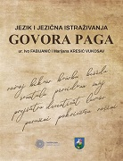

Author | Fabijanić, Ivo et al.
Title | Jezik i jezična istraživanja govora Paga
Publisher | Zadar : Sveučilište u Zadru ; Pag : Grad Pag, 2026
Description | 212 str. : zemljop. crteži u bojama, graf. prikazi u bojama ; 27 cm
ISBN | 9789533316031 : EUR 29.80 US$ 35.20
Subject | Hrvatski jezik -- Narječja -- Pag (otok). Čakavsko narječje -- Pag (otok)
UDC | 811.163.42'282.2(497.581.1Pag)

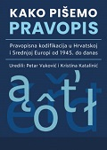
Author | Vuković, Petar (urednik) (autor teksta)
Title | Kako pišemo pravopis : pravopisne kodifikacije u Hrvatskoj i Srednjoj Europi od sredine XX. stoljeća do danas
Publisher | Zagreb : Srednja Europa, 2026
Description | VI, 347 str. ; 24 cm
ISBN | 9789533870885 : EUR 37.10 US$ 43.80
UDC | 81'35(4)(091) * 811.163.42'35(091) * 811.16'35(091) * 81'26(4)(091)
Anotation | The collective monograph Kako pišemo pravopis (How We Write: Orthography) explores how orthographic codification is shaped and transformed in Croatia and in culturally related Central European linguistic communities, particularly from the mid-20th century to the present. Proceeding from the premise that orthography is a "technical" matter yet simultaneously a potent social symbol, the authors analyze the situations in which orthography becomes an issue of language policy, who initiates debates surrounding it, how normative solutions are adopted and implemented, and how their effects are evaluated under different regimes.

Literature. History. Theory
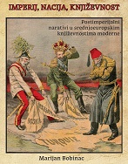
Author | Bobinac, Marijan
Title | Imperij, nacija, književnost : postimperijalni narativi u srednjoeuropskim književnostima moderne
Publisher | Zagreb : Srednja Europa, 2026.
Description | 381 str. ; 24 cm
ISBN | 9789533870700 : EUR 29.80 US$ 35.20
Subject | European literature -- Central Europe. Modernism (literature) – Europe. Politics in literature  National identity in literature
UDC | 821(4).09 * 821(4).02"19"

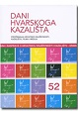
Title | Dani Hvarskoga kazališta – knjiga 52  Prožimanja hrvatske književnosti, kazališta, filma i medija  / [uredništvo knjige Boris Senker, Lucija Ljubić, Vinka Glunčić-Bužančić]
Publisher | Zagreb : Hrvatska akademija znanosti i umjetnosti ; Split : Književni krug, 2026
Description | 410 str. : 20 cm
ISBN | 9789533476681 : EUR 10.70 US$ 12.60
Serie | Dani Hvarskoga kazališta – knjiga 52
UDC | 821.163.42-1 * 821.163.42-3

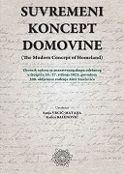
Title | Suvremeni koncept domovine : (The Modern Concept of Homeland) : zbornik radova sa znanstvenog skupa povodom 200. obljetnice rođenja Ante Starčevića, Gospić, 26.-27. svibnja 2023.  /Vrcić-Mataija, Sanja (urednik) (autor predgovora) ; Balenović, Katica (urednik) (autor predgovora)
Publisher | Zadar : Sveučilište u Zadru, Odjel za nastavničke studije u Gospiću, 2025
Description | 340 str. ; 24 cm.
Note | Summaries ; Sažeci. Kazalo. Napomena o jeziku i pismu. Tekst na hrv. i na engl. jeziku.
ISBN | 9789533315706 : EUR 47.60 US$ 56.20
Subject | Starčević, Ante, političar. Hrvatska rodoljubna književnost -- Zbornici s konferencija  Hrvatski jezik -- Zbornici s konferencija. Hrvatska -- U književnosti -- Zbornici s konferencija
UDC | 821.163.42.09 * 94(497.5)Starčević, A. * 32Starčević, A. * 81Starčević, Š.
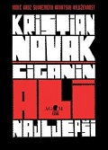

Author | Lokotar, Kruno (urednik)
Title | Vodič kroz suvremenu hrvatsku književnost : Kristian Novak: Ciganin, ali najljepši‎
Publisher | Zagreb : Zagrebački holding, Podružnica AGM, 2026
Description | 150 str. : ilustr. ; 25 cm + [1] višestruko presavijen list sa stihovima
ISBN | 9789531745352 : EUR 31.80 US$ 37.50
Subject | Novak, Kristian Ciganin, ali najljepši. Novak, Kristian -- Interpretacije i kritike
UDC | 821.163.42.09Novak, K. * 821.163.42-4

Literature. Poetry
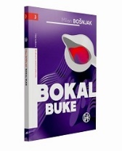
Author | Bošnjak, Milan
Title | Bokal buke : odabrane pjesme 1986. - 2022
Publisher | Zagreb : Društvo hrvatskih književnika, 2026
Description | 138 str. ; 21 cm
ISBN | 9789532784558 : EUR 11.90 US$ 14.00
Subject | Dijalektalno pjesništvo
UDC | 821.163.42-1 * 821.163.42-1'282

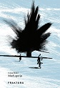
Author | Đikić, Ivica
Title | Međugorje
Publisher | Zaprešić : Fraktura, 2026
Description | 112 str. : 21 cm
Note | Stihovi
ISBN | 9789533589824 : EUR 16.00 US$ 18.90
UDC | 821.163.42-1

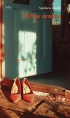
Author | Radetić, Snježana
Title | Ničija Zemlja
Publisher | Zagreb : Hrvatsko društvo pisaca, 2026
Description | 109 str. ; 20 cm
Note | Stihovi
ISBN | 9789538152764 : EUR 14.30 US$ 16.90
UDC | 821.163.42-1

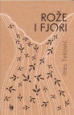
Author | Teković, Ines
Title | Rože i fjori
Publisher | Zagreb : Naklada Jesenski i Turk, 2025
Description | 91 str. ; 20 cm
Note | Stihovi
ISBN | 9789533811185 : EUR 13.80 US$ 16.30
UDC | 821.163.42-1

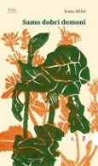
Author | Miloš, Ivana
Title | Samo dobri demoni
Publisher | Zagreb : Hrvatsko društvo pisaca, 2026
Description | 85 str. ; 20 cm
Note | Stihovi
ISBN | 9789538152771 : EUR 14.30 US$ 16.90
UDC | 821.163.42-1

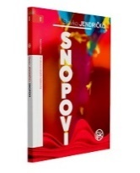
Author | Jendričko, Slavko
Title | Snopovi
Publisher | Zagreb : Društvo hrvatskih književnika, 2026
Description | 132 str. ; 21 cm
Note | Pjeme u prozi
ISBN | 9789532784596 : EUR 21.40 US$ 25.20
UDC | 821.163.42-16

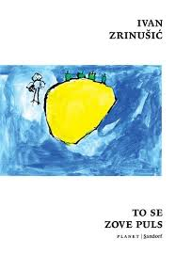
Author | Zrinušić, Ivan
Title | To se zove puls
Publisher | Zagreb : Sandorf, 2026
Description | 112 str. ; 17 cm
Note | Stihovi
ISBN | 9789533516080 : EUR 10.60 US$ 12.50
UDC | 821.163.42-1 * 821.163.42-16

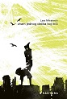
Author | Mitraković, Lara
Title | Znam jednog dečka koji trči
Publisher | Zaprešić : Fraktura, 2026
Description | 104 str. : 20 cm
Note | Stihovi
ISBN | 9789533589831 : EUR 16.00 US$ 19.00
UDC | 821.163.42-1

Literature. Prosa. Novels. Short stories. Essays.

Author | Peričić, Denis
Title | Babelj, Bruno, Berija : konstruktivni roman - ruski kolaž
Publisher | Zagreb : Disput, 2026
Description | 212 str. : ilustr. ; 21 cm
ISBN | 9789532605310 : EUR 21.30 US$ 25.10
UDC | 821.163.42-31
Anotation | While the phenomenon of the Russian avant-garde has been thoroughly studied in Croatia, literary works dealing with this period are rare. This is precisely the subject of Denis Peričić’s novel.  The author has attempted to tell the story of the Russian avant-gardists their triumphs, hardships, and romances in the very style they used themselves, or perhaps in the way many of them might have written had Stalin not liquidated them.
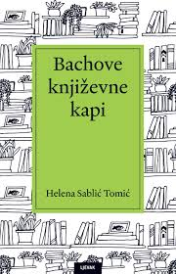

Author | Sablić Tomić, Helena
Title | Bachove književne kapi
Publisher | Zagreb : Naklada Ljevak, 2026
Description | 295 str. ; 22 cm
ISBN | 9789533559636 : EUR 29.30 US$ 34.60
UDC | 821.163.42-4 * 821.163.42.09
Anotation | Helena Sablić Tomić’s Bachove književne kapi (Bach’s Literary Drops) guides you through the alluring world of books that heal sorrow, spark curiosity, and transform reading into a ritual of pleasure. Discover a literary "apothecary" where every page offers a respite from the everyday and opens the way to a richer inner life.  Bachove književne kapi is a collection of mini-essays and critiques concerning contemporary Croatian writers these writings serve as a starting point for reflections on the places, methods, forms, and moments of reading, as well as the scents and flavors that drift around a book.

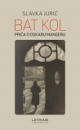
Author | Jurić, Slavka
Title | Bat kol : priča o Oskaru Mangeru
Publisher | Zagreb : Leykam international, 2026
Description | 195 str. ; 21 cm
ISBN | 9789533402369 : EUR 23.80 US$ 28.10
UDC | 821.163.42-31
Anotation | Oskar Manger was a composer of Jewish descent, born in Trieste in 1910. We are introduced to his life story by his granddaughter, who only discovered her blood connection to the composer in her adult years.  This is a biographical novel blending fact and fiction about Judaism, Catholicism, the Holocaust and war, love, and music.


Author | Bauer, Ljudevit
Title | Biserje za Karolinu ili Križni put Borisa Brucknera
Publisher | Zagreb : Bodoni, 2026
Description | 220 str. ; ilustr. ; 21 cm
ISBN | 9789538398667 : EUR 24.50 US$ 28.90
UDC | 821.163.42-31
Anotation | Biserje za Karolinu (Pearls for Karolina) by Ludwig Bauer is a political novel about power, language, manipulation and love against the backdrop of the collapse of collectivism and the rise of nationalism. Through Boris Bruckner and Karolina Bauer, he writes a powerful story about government, populism and the destinies of our areas.


Author | Špoljar, Željko
Title | Caffé bar Utrine
Publisher | Zagreb : Društvo hrvatskih književnika, 2026
Description | 142 str. ; 21 cm
ISBN | 9789532784527 : EUR 22.60 US$ 26.70
UDC | 821.163.42-31
Anotation | In his new novel Caffe bar Utrine, Željko Špoljar continues to dissect everyday life in Zagreb from the vantage point of a bar counter. The author uses this iconic neighborhood as a backdrop for a gallery of characters ranging from washed-up intellectuals and local drunks to modern-day groupies all seeking meaning in the local café. Just as in his previous works, the focus remains on people who exist outside the mainstream, yet whose destinies mirror society itself.

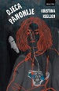
 | Kegljen, Kristina
Title | Djeca Panonije
Publisher | Zagreb : Hena com, 2026
Description | 255 str. ; 22 cm
ISBN | 9789532595802 : EUR 23.30 US$ 27.50
UDC | 821.163.42-31
Anotation | Kristina Kegljen’s novel Djeca Panonije (Children of Pannonia) begins as an innocuous tale of an unconventional upbringing on the fringes of stagnation, yet like the swollen waters of the Sava it spills over into the murky depths of agony experienced by those who have given up on themselves and those who have walked away from their own lives. Drawing on the acerbity and dark humor of obscure sources, a mystery-seeker is led not only to a resolution but also to a new rhythm of life.

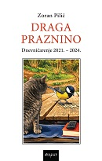
Author | Pilić, Zoran
Title | Draga Praznino : dnevničarenje (1. 8. 2021. - 11. 8. 2024.)
Publisher | Zagreb : Disput, 2026
Description | 277 str. ; 21 cm
ISBN | 9789532605341 : EUR 23.40 US$ 27.60
UDC | 821.163.42-94
Anotation | Draga praznino (Dear Emptiness) is a journal of observations regarding other books the author reads and the films and series he watches, as well as to a lesser extent a record of what he is writing or attempting to write. By force of circumstance, Draga praznino is also a chronicle of life during the pandemic. Ultimately, the commentary on the reality surrounding us might create the impression a mistaken one, the author hopes that this is also a diary of civilization’s slow decline or its descent into an era of idiocracy.

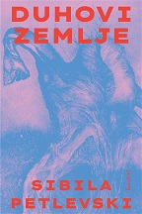
Author | Petlevski, Sibila
Title | Duhovi zemlje
Publisher | Zagreb : Sandorf, 2026
Description | 646 str. ; 22 cm
ISBN | 9789533516165 : EUR 30.90 US$ 36.50
UDC | 821.163.42-31
Anotation | Duhovi zemlje (Spirits of the Earth) is a compelling polyphonic novel a kind of "atlas" of magical realism where the exotic landscapes of Bolivia merge with Zagreb during the infamous NDH era. It is a saga about heroines from a dark age women such as the Baković sisters, as well as Rajka’s Indigenous wet nurse and the latter’s great-granddaughter in contemporary Bolivia set against the backdrop of a bloody clash between differing faiths and political ideologies.


Author | Tolić, Tanja
Title | Fi
Publisher | Zagreb : Hena com, 2026
Description | 191 str. ; 22 cm
ISBN | 9789532595857 : EUR 21.20 US$ 25.00
UDC | 821.163.42-31
Anotation | Through the eyes of a curious and perceptive young girl, we follow a working-class family in the 1980s—a time of optimism and progress marked by the purchase of their first "Tristać" car, moving into a new apartment, and summer holidays at workers' resorts. Within the broader social context, new urban structures clash with the legacy of deeply ingrained rural values. When the family faces an unknown situation that must be kept secret, the girl confronts voids of fear and loneliness, defending herself with imagination and wit.

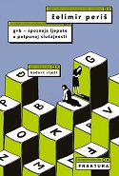
Author | Periš, Željko
Title | Gvb – spoznaja ljepote u potpunoj slučajnosti
Publisher | Zaprešić : Fraktura, 2026
Description | 312 str. ; 21 cm
ISBN | 9789533589855 : EUR 24.50 US$ 28.90
UDC | 821.163.42-31
Anotation | Gvb – spoznaja ljepote u potpunoj slučajnosti (Gvb – The Discovery of Beauty in Pure Chance) is the new novel by Želimir Periš, in which an unusual discovery on the ocean floor draws Danica into a whirlwind of science, poetry, and global politics. Playing with words, grammar, and chance, Periš crafts a witty, bizarre, and entirely original novel about love, the world, and—*gvb*.


Author | Šovagović-Despot, Anja
Title | Ja, barunica Castelli
Publisher | Zagreb : Matica hrvatska, 2026
Description | 201 str. ; 24 cm
ISBN | 9789533413228 : EUR 23.80 US$ 28.10
UDC | 821.163.42-31
Anotation | The novel Ja, barunica Castelli (I, Baroness Castelli) by Croatian actress and writer Anja Šovagović Despot explores and rehabilitates the most reviled woman in Croatian literature a character from Krleža’s Gospoda Glembajevi (The Glembays) by questioning why generations of readers have unquestioningly believed Leone rather than her. The author seeks to uncover what Miroslav Krleža left unsaid about the baroness, giving her a voice and transforming her from a stereotypical figure into the complex protagonist of her own story.


Author | Brnardić Oproiu, Ana
Title | Jezero
Publisher | Zagreb : Naklada OceanMore, 2026
Description | 142 str. ; 21 cm
ISBN | 9789533322353 : EUR 22.70 US$ 26.80
UDC | 821.163.42-31
Anotation | In her prose debut, the short autofictional novel Jezero (The Lake), Ana Brnardić grapples with one of the most daunting challenges a writer can face: how to powerfully render, through text, the devastating void that opens up the moment we realize a loved one is dying.


Author | Ribić, Tomislav
Title | Kornjača u staklenci šutnje
Publisher | Zagreb : Disput, 2026
Description | 359 str., [6] listova s tablama : fotogr. ; 21 cm
Note | Mali rječnik kajkavizama i varaždinskog kihendojča: str. 351-356.
ISBN | 9789532605303 : EUR 26.60 US$ 31.40
UDC | 821.163.42-3
Anotation | In this novel-saga, personal destiny transforms into a space of testimony where history is narrated through scattered fragments of memory and silence, through letters and photographs that have slipped from the family album. Family silence becomes one of the book’s key languages: it conceals the fears, losses, and memories of adults things the children only begin to understand later on. Growing up turns into a whirlwind of departures and overnight disappearances.

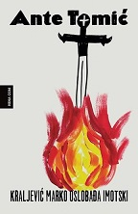
Author | Tomić, Ante
Title | Kraljević Marko oslobađa Imotski
Publisher | Zagreb : Hena com, 2026
Description | 184 str. ; 21 cm
ISBN | 9789532595833 : EUR 21.20 US$ 25.00
UDC | 821.163.42-31
Anotation | Ante Tomić’s new novel, Kraljević Marko oslobađa Imotski (Prince Marko Liberates Imotski), is a satire that strikes exactly where it hurts the most. Through a cast of unforgettable characters in the story of Imotski’s “liberation,” he lays bare our mentalities, myths, and well-known weaknesses—using a devastating humor that makes us laugh to the point of tears while simultaneously shattering our illusions.


Author | Mlakić, Josip
Title | Legenda o planini
Publisher | Zaprešić : Fraktura, 2026
Description | 184 str. ; 22 cm
ISBN | 9789533589787 : EUR 26.60 US$ 31.40
UDC | 821.163.42-36
Anotation | Josip Mlakić’s *The Legend of the Mountain* is a travelogue that blends nature, personal experience, and cultural heritage. Through Mount Vranica, the author takes the reader on a journey interwoven with myths, wartime memories, and oral tradition, creating a meditative work about time, faith, collective memory, and the power of the landscape.

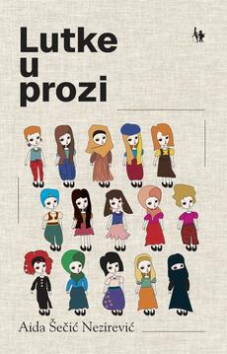
Author | Šečić Nezirević, Aida
Title | Lutke u prozi
Publisher | Zagreb : Naklada Jesenski i Turk, 2026
Description | 180 str. ; 20 cm
ISBN | 9789533811222 : EUR 17.00 US$ 20.10
UDC | 821.163.43-055.2-36
Anotation | Following her successful poetry collection *Lutke* (Dolls), the author reaffirms her storytelling prowess and mature artistic voice with a collection of no fewer than 32 short stories. Each story bears a woman's name, and together they form a mosaic of the female experience in all its varied shades. The author presents a gallery of characters women of diverse nationalities, religious backgrounds, and social strata whose life stories raise questions regarding love and violence in relationships, childhood, motherhood, illness and old age, shame and liberation, and the realities of war and its aftermath.

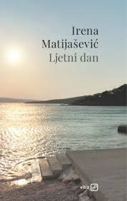
Author | Matijašević, Irena
Title | Ljetni dan
Publisher | Zagreb : V. B. Z., 2026
Description | 153 str. ; 21 cm
ISBN | 9789535209188 : EUR 22.60 US$ 26.70
UDC | 821.163.42-36
Anotation | Irena Matijašević’s new book is a tribute to Danijel Dragojević—a poet who profoundly shaped Croatian poetry in the 20th and 21st centuries, as well as a conversation partner and mentor who influenced the author’s professional development as the editor of the cult radio programs *Poezija naglas* (Poetry Aloud) and *Riječi i riječi* (Words and Words). The novel connects key figures in the writer’s life—the poet and her father—who serve as sources of inspiration yet also embody authority figures whose shadow the author steps out of in search of her own liberated voice.


Author | Jeremić Cebalo, Marija
Title | Mi djeca predplastičnog doba : roman na osnovu istinitih događaja
Publisher | Split : Naklada Bošković, 2026
Description | 247 str. ; 21 cm
ISBN | 9789532638073 : EUR 29.80 US$ 35.20
UDC | 821.163.42-31
Anotation | The novel *We, Children of the Pre-Plastic Era* is an autobiographical work by author Marija Jeremić Cebalo. This regional narrative is based on true events and offers a heartwarming portrayal of growing up, daily life, and local customs on the island of Korčula (particularly in Žrnovo) prior to the modern technological age.


Author | Čeko, Anita
Title | Nagrada Marin Držić : Hrvatska drama 2025.
Publisher | Zagreb : Disput, 2026
Description | 414 str. ; 21 cm
Note | Ostali zastupljeni autori: Monika Herceg, Hrvoje Kovačević, Nikolina Rafaj, Ivana Sajko, Tomislav Zajec
ISBN | 9789532605334 : EUR 21.30 US$ 25.10
UDC | 821.163.42-2(082)


Author | Popović, Edo
Title | Nema mačaka lutalica u Švicarskoj
Publisher | Zagreb : Libricon, 2025
Description | 117 str. : ilustr. ; 20 cm
ISBN | 9789538017308 : EUR 17.70 US$ 20.90
UDC | 821.163.42-94
Anotation | Genre-diverse and soothing—standing in defiance of today’s turbulent times and heated rhetoric—this book will delight all admirers of Edin’s writing style and his worldview.

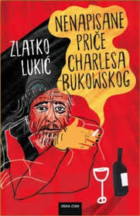
Author | Lukić, Zlatko
Title | Nenapisane priče Charlesa Bukowskog
Publisher | Zagreb : Hena com, 2026
Description | 135 str. ; 22 cm
ISBN | 9789532595765 : EUR 21.20 US$ 25.00
UDC | 821.163.4(497.6)-32
Anotation | Nenapisane priče Charlesa Bukowskog (Charles Bukowski’s Unwritten Stories) is a high-risk literary project in which the boundary between myth and authenticity is deliberately blurred. The voice speaking from these pages is raw, vulgar, brutal, and too convincing to be merely a literary construct. If this is a hoax, then it is a perfect one. If not, then we have just gained another Bukowski.

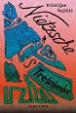
Author | Vujičić, Kristijan
Title | Nietzsche s Trešnjevke
Publisher | Zaprešić : Fraktura, 2026
Description | 224 str. ; 21 cm
ISBN | 9789533589732 : EUR 24.50 US$ 28.90
UDC | 821.163.42-31
Anotation | Nietzsche s Trešnjevke (Nietzsche from Trešnjevka) is a novel about unfulfilled dreams and love found in the most unexpected places; a novel about aging, dignity, and moments of warmth, as well as the idea that philosophy is not in vain and that kindness always pays off.

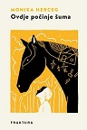
Author | Herceg, Monika
Title | Ovdje počinje šuma : prva kuća
Publisher | Zaprešić : Fraktura, 2026
Description | 247 str. ; 21 cm
ISBN | 9789533589565 : EUR 24.50 US$ 28.90
UDC | 821.163.42-31
Anotation | Ovdje počinje šuma (Here the Forest Begins) is an intimate and unsparing chronicle of poverty, violence, and exile, a story of women who endure, houses that vanish, and memories that keep growing from the ashes. Monika Herceg has written a powerful, lyrical, and deeply moving novel about growing up in the shadow of family and historical trauma, but above all, about a language born from things, from bodies, and from the stories of our ancestors.

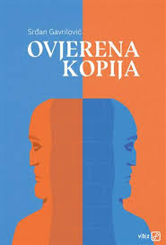
Author | Gavrilović, Srđan
Title | Ovjerena kopija
Publisher | Zagreb : V. B. Z., 2026
Description | 235 str. ; 20 cm.
ISBN | 9789535209034 : EUR 22.60 US$ 26.70
UDC | 821.163.4(497.6)-31
Anotation | With the novel Ovjerena kopija (Certified Copy), Gavrilović has succeeded in crafting a remarkably timely work that skillfully encapsulates contemporary anxieties, insecurities, and fears. Through it, he further solidifies his status as the unique voice of a disillusioned and displaced generation living in a world where—as a character in the novel puts it—"the air smelled of war, and I had no desire to return home."

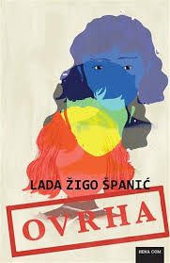
Author | Žigo Španić, Lada
Title | Ovrha
Publisher | Zagreb : Hena com, 2026
Description | 232 str. ; 22 cm
ISBN | 9789532595895 : EUR 23.30 US$ 27.50
UDC | 821.163.42-31
Anotation | The dystopian novel Ovrha (Foreclosure) is set in a dehumanized world ruled by a muted form of totalitarianism and the control of actions and thoughts, where the loss of individuality leads to spiritual desolation. When a forced debt collection arrives at Ava’s doorstep, the novel’s protagonist discovers that a mysterious debt is linked to her name and that many others have been subjected to the same foreclosure process. At the same time, the world is changing—slowly but surely...

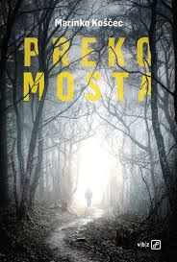
Author | Koščec, Marinko
Title | Preko mosta
Publisher | Zagreb : V. B. Z., 2026
Description | 275 str. ; 21 cm
ISBN | 9789535209072 : EUR 24.90 US$ 29.40
UDC | 821.163.42-31
Anotation | The novel Preko mosta interweaves the seemingly incompatible: immersion in heritage, projections of the future, the issue of immigrants in our midst and the penetration of artificial intelligence into our lives.


Author | Uzelac, Maja
Title | Priče, kronike, eseji
Publisher | Zagreb : Naklada Jesenski i Turk, 2026
Description | 293 str. ; 20 cm
ISBN | 9789533811284 : EUR 23.40 US$ 27.60
UDC | 821.163.42-82(081) * 821.163.42-32 * 821.163.42-4
Anotation | The quality of Maja Uzelac’s stories stems from her skillful use of postmodernist elements, both in her storytelling and in the themes she explores. Yet, all these "heavy" subjects are infused with humor, irony, and self-irony, so the reader does not perceive them as burdensome but simply enjoys her storytelling.

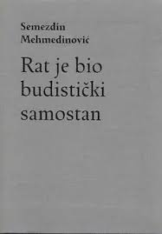
Author | Mehmedinović, Semezdin
Title | Rat je bio budistički samostan
Publisher | Zagreb : Multimedijalni institut : Kulturtreger, 2026
Description | 265 str. ; 19 cm.
ISBN | 9789538469213 : EUR 23.80 US$ 28.10
UDC | 821.163.43-82(081) * 821.163.43-3
Anotation | The book *War Was a Buddhist Monastery* is a collection of prose pieces and essays by the prominent Bosnian-Herzegovinian and American writer, published in 2026 by the Multimedia Institute. As in his previous cult works, the author blends universal, cosmopolitan themes with deeply personal family and autobiographical details.

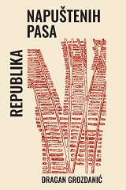
Author | Grozdanić, Dragan
Title | Republika napuštenih pasa
Publisher | Zagreb : Srpsko narodno vijeće : Sandorf, 2025
Description | 139 str. ; 21 cm.
ISBN | 9789537442835 : EUR 19.20 US$ 22.70
UDC | 821.163.42-36
Anotation | Republika napuštenih pasa (The Republic of Abandoned Dogs) grew out of reportage newspaper pieces written for a print weekly, always under tight deadlines and strict word-count limits, yet always holding the clear outlines of a story waiting to be explored and nuanced through direct, living contact. A literary heart beats within Dragana Grozdanić’s reportage; the texts are richer, more tender, more poetic, and more thoughtful than even the finest reportage strictly requires. Each original piece was already woven from stories, any one of which could be and in a sense is a novel, albeit an unwritten one.

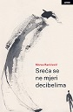
Author | Banićević, Morea
Title | Sreća se ne mjeri decibelima
Publisher | Zagreb : Naklada Ljevak, 2026
Description | 157 str. ; 22 cm
ISBN | 9789533559650 : EUR 26.90 US$ 31.70
UDC | 821.163.42-31
Anotation | The collection of short stories for adults, Sreća se ne mjeri decibelima (Happiness is not measured by decibels), by Morea Banićević, is framed by stories about an unusual writer (is anyone ordinary?) who ends up signing an even more unusual publishing contract. This (auto) ironic streak already indicates noticing the details of everyday life or, more precisely, what that life may or may not be.

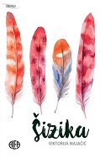
Author | Majačić, Viktorija
Title | Šizika
Publisher | Zagreb : Alfa, 2026
Description | 147 str. ; 20 cm
ISBN | 9789533646282 : EUR 21.30 US$ 25.10
UDC | 821.163.42-31
Anotation | The novel Šizika is not merely a literary work—it is a space of profound empathy, understanding, and unobtrusive support. It is a book that some may pick up with trepidation, yet many will finish with tears, relief, and a smile. For, as the author demonstrates, the place of greatest pain is—paradoxically—also the place that opens up the greatest space for love, acceptance, and hope.


Author | Zrinušić, Ivan
Title | Špranje : (2020. - 2023.)
Publisher | Zagreb : Durieux, 2026
Description | 163 str. ; 20 cm
ISBN | 9789531886116 : EUR 20.10 US$ 23.70
UDC | 821.163.42-4
Anotation | *Špranje* by Ivan Zrinušić is a collection of essays written between 2020 and 2023 that brings together philosophical reflections, cultural criticism, personal experiences, and lyrical miniatures. The essays explore reading as an act of empathy, writers and their shadows, and the value of art in an age of speed and superficiality. These texts demonstrate that literature—even if it cannot save us from ruin—can nonetheless alter perceptions, deepen consciousness, and shape the reader. *Špranje* is a book for the attentive reader; it offers no ready-made answers, yet it opens up fissures through which we may glimpse meaning.

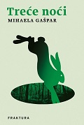
Author | Gašpar, Mihaela
Title | Treće noći
Publisher | Zaprešić : Fraktura, 2026
Description | 163 str. ; 21 cm
ISBN | 9789533589138 : EUR 23.40 US$ 27.60
UDC | 821.163.42-31
Anotation | From the very first sentence, we sense that something bad has happened—something that drove the narrator to leave, to withdraw from the world of people, from everyday life, and from the very thing that triggered the tragedy. The reader can only surmise the nature of this tragedy while delving deeper into the protagonist's past and present. In the novel Treće noći (The Third Night), Mihaela Gašpar once again proves herself a master of characterization and of understanding the depths of the human soul.


Author | Čilić, Đurđica
Title | Vidimo se na papiru
Publisher | Zagreb : V.B.Z, 2026
Description | 157 str. ; 21 cm
ISBN | 9789535209003 : EUR 21.50 US$ 25.40
UDC | 821.163.42-31
Anotation | Đurđica Čilić’s book of autobiographical stories and notes, Vidimo se na papiru (See You on Paper), leads us through the same prose landscape that the author described so evocatively in her two previous books, *Fafarikul* and *Novi kraj*.

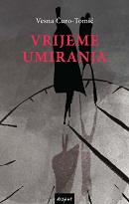
Author | Ćuro-Tomić, Vesna
Title | Vrijeme umiranja
Publisher | Zagreb : Disput, 2026
Description | 213 str. ; 21 cm
ISBN | 9789532605259 : EUR 21.30 US$ 25.10
UDC | 821.163.42-31
Anotation | It is hardest for a person to come to terms with the agonizing death of those they love. This diary chronicles the passing of one’s parents,first the father, then the mother with unflinching, even ruthless, candor. Its purpose is not to lament the past, but to serve as a story for those yet to experience such a loss: so they may know they are not to blame.

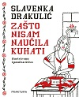
Author | Drakulić, Slavenka
Title | Zašto nisam naučila kuhati
Publisher | Zaprešić : Fraktura, 2026
Description | 148 str. ; 22,5 cm
ISBN | 9789533589640 : EUR 26.60 US$ 31.40
Anotation | Zašto nisam naučila kuhati (Why I Didn't Learn to Cook) by Slavenka Drakulić is a warm, witty, and feminist book about cooking, growing up, the patriarchy, and kitchen memories. From her grandmother’s and mother’s kitchens to her first banana in Italy, the author explores why she never learned to cook and whether the way to the heart really must go through the stomach.

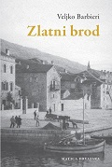
Author | Barbieri, Veljko
Title | Zlatni brod : pustolovine noštroma Ivana koji je „četrdesetipet“ puta oplovio svijet i doživio „stodvadesetičetiri“ pustolovine
Publisher | Zagreb : Matica hrvatska, 2026
Description | 179 str. ; 21 cm
ISBN | 9789533413167 : EUR 23.80 US$ 28.10
UDC | 821.163.42-31'282
Anotation | Zlatni brod (The Golden Ship) is a nostalgic, witty, and linguistically impressive novel about life, the sea, and dreams.

Arts. Drawings
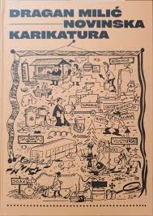
Author | Čakširan, Vlatko
Title | Dragan Milić : novinska karikatura : [monografija]
Publisher | Sisak : Gradski muzej, 2025
Description | 115 str. : ilustr. ; 30 cm
ISBN | 9789538389269 : EUR 27.00 US$ 32.90
Subject | Milić, Dragan, karikaturist. Novine -- Karikature -- Hrvatska
UDC | 741.5Milić, D. * 741.5(497.5)

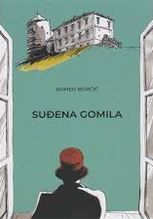
Author | Borčić, Romeo
Title | Suđena gomila
Publisher | Split : Naklada Bošković, 2026
Description | 259 str. : ilustr. ; 28 cm
Note | Strip
ISBN | 9789532638097 : EUR 26.20 US$ 30.90
UDC | 741.52(497.5)

Theatar. Film. Dance
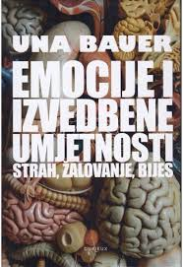
Author | Bauer, Una
Title | Emocije i izvedbene umjetnosti : strah, žalovanje, bijes
Publisher | Zagreb : Durieux, 2025
Description | 271 str. : ilustr. ; 24 cm
ISBN | 9789531885850 : EUR 24.30 US$ 28.70
UDC | 792/793 * 792.01 * 792.8.01
 | In Emotions and Performing Arts — Fear, Grief, and Rage, Una Bauer proceeds from the critical premise that both the purely cognitive (traditionally dominant) and the purely emotional, sensualist approaches to art are methodologically and epistemologically inadequate for systematically addressing the phenomena of post-dramatic theatre. As post-dramatic theatre has become the dominant aesthetic practice on the European continent, it has introduced considerable discord into traditional theatre studies circles, which lacked the analytical tools to engage with this new phenomenon. To address this challenge and remedy the theoretical shortcomings of certain strands of traditional theatre studies, the author draws upon the complex, interdisciplinary field of affect studies.


Author | Juričić, Toni
Title | Karneval, eksces, zazor : groteska u (post)jugoslavenskoj kinematografiji
Publisher | Zagreb : Hrvatski filmski savez : Društvo hrvatskih filmskih autora i producenata, 2025
Description | 244 str. : ilustr. (pretežno u bojama) ; 24 cm
ISBN | 9789537033798 : EUR 27.40 US$ 32.30
Subject | Groteska na filmu. Jugoslavenska kinematografija. Kinematografija -- Zemlje bivše Jugoslavije
UDC | 791(497.1) * 791(4)


Author | Ramljak, Ozana
Title | Rječnik filmskoga žargona
Publisher | Zagreb : Institut za hrvatski jezik, 2026
Description | 361 str. ; 24 cm
ISBN | 9789537967055 : EUR 16.00 US$ 18.90
Subject | Filmska umjetnost -- Rječnici
UDC | 791(038)


Author | Lončar, Karla (urednik)
Title | Umijeće filmologije : zbornik u čast Hrvoju Turkoviću
Publisher | Zagreb : Akademija dramske umjetnosti : Hrvatska sveučilišna naklada, 2026
Description | 297 str. : ilustr. ; 24 cm
ISBN | 9789538196522 : EUR 21.30 US$ 25.10
Subject | Turković, Hrvoje -- Zbornici s konferencija. Teorija filma -- Zbornici s konferencija
UDC | 791.072Turković, H. * 791.01

